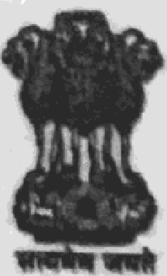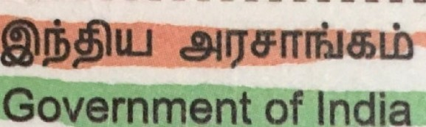
Scanned by CamScanner

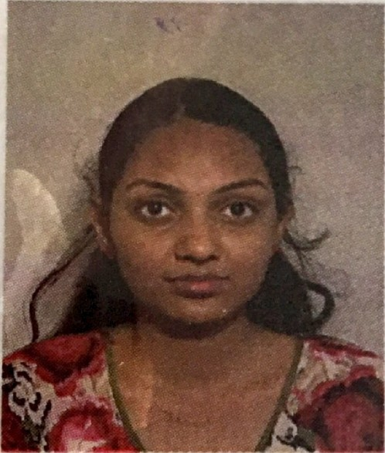
Koka Ravalika Sai

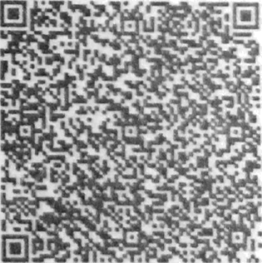
I3ljT/jji@ gKétl / DOB: 14/01/1996

Gueiéunais / Female

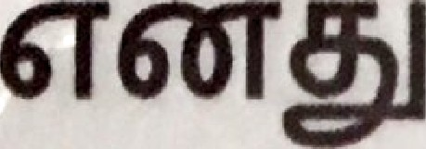
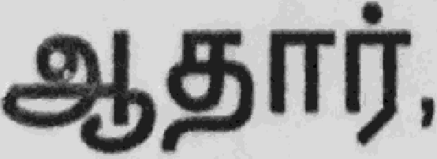
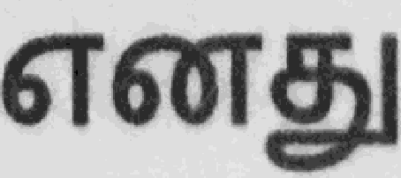
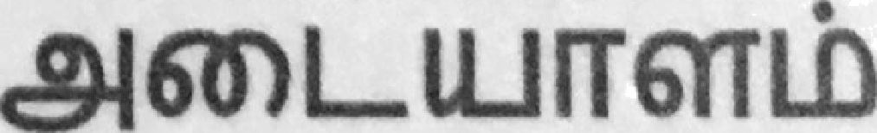

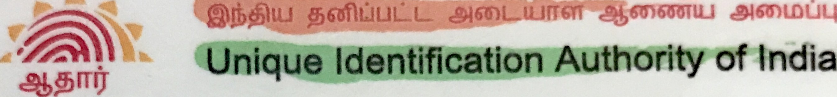

6tXI119

1947
L
Address: D/O: Koka Sarath Chandra Sai, SATHYABAMA UNIVERSITY, Sholinganallu r, Kancheepuram, Sholinganallur, Tamil Nadu, 600119

7260 2020 4585


helpRuldal.gov.In 